Teacher Training Day: Sharing Good Practices in Teaching Chinese Language

and Cultures in the AI Era

(Hybrid)
Seminar Room 10, Bowland North, Lancaster University, and Online

Friday 25 April 2025

Training Day Languages: English and Chinese

Training Day Schedule
09.30 – 09.50 In person attendees arrive, register, get refreshments and are seated for 09.50.
09.40 – 09.50 Event opens to online registrants.
09.50 – 10.00 Welcome
10.00 – 12.15 Presentations
12.15 – 1.15 Lunch
1.15 – 15.30 Presentations
15.30-15.45 Break
15.45-16.55 Lightning talks or discussions
16.55-17.00 Conclude

Order of presentation

10.00 – 10.45 Innovative Approach to Teaching Chinese Culture through the Integration of Cultural
MOOCs and AI Technologies (in English)
Dr. Luo Rong (Associate Professor at the School of International Studies, Zhejiang University)
Dr. Li Wenjing (Associate Professor at the College of International Education, Hangzhou Normal University)
This presentation will introduce MOOC-based blended teaching approaches at Chinese universities to enhance the efficiency and quality of teaching Chinese culture to Chinese students and international students. The cultural MOOC The Breeze from the East was developed by our teaching group, consisting of 12 chapters covering a broad spectrum of topics in both traditional and contemporary Chinese culture. The presentation will also highlight ongoing efforts to integrate AI technologies into teaching practices in recent 1-2 years. These include using AI to intelligently segment and recommend teaching resources, design test questions, and evaluate students' learning outcomes. By combining the strengths of MOOCs and AI, this innovative approach seeks to create an upgraded, dynamic and effective model for teaching Chinese culture in the digital era.
10.45 – 11.30 Practical Exploration of AI Agents in the Field of International Chinese Education
(in Chinese)
Mr. Xie Junjie (General Manager of Taoli Chinese)
This presentation will focus on the application of Artificial Intelligence Agents (AI Agents) in the field of international Chinese education and explore how to improve teaching efficiency and quality through technological innovation. It explores how the AI question-generating system based on large language models can achieve intelligent grading, quickly generate a vast number of test questions and simultaneously provide scoring standards, so as to cope with time-consuming traditional test design and heavy reliance on manpower. It also introduces how the intelligent scoring Agents can ensure the objectivity and accuracy of evaluations through multi-dimensional data analysis. The speech will combine the practice of the TaoLi AI product of the "Taoli Chinese" team to analyze the technical architecture and ethical challenges of AI Agents in educational scenarios, such as how to balance automation and teachers' dominance and ensure the originality of test design. It will look forward to the future potential of AI Agents in Chinese teaching and research, emphasizing the collaborative evolution of "teaching" and "learning" empowered by technology.

11.30-12.15 Combination Punch and Differentiation Strategy: How Chinese Language Teachers

Address Opportunities and Challenges in the AI Era (in English)
Chen Ye (formerly dispatched Mandarin Teacher at the Confucius Institute of Peking University and UCL)
This lecture will share the speaker’s practical experience in using over a dozen AI language teaching tools to enhance the motivation and Chinese proficiency of GCSE, A-Level, and HSK students. It will also introduce specific methods and resource-sharing on how to leverage generative AI tools like Deepseek and ChatGPT to assist in lesson preparation, create teaching materials, and provide feedback on corrections. While AI tools excel in personalized learning, their limitations in emotional interaction highlight the growing importance of teachers’ empathy skills in the future. The speaker will further explore how to optimize language and intercultural communication teaching through empathy theory, reinforcing the unique value of teachers to meet the new challenges posed by the AI era to the competency framework of language educators.

12.15-13.15 Lunch in the Roundhouse Kitchen for in-person attendees

13.15-14.00 Foreign Language Speaking Anxiety Online (in English)
Dr Zsuzsanna Bárkányi (Senior Lecturer in Spanish, The Open University)

Have you ever wondered why your students hesitate to speak in the classroom? Why nobody responds on a forum? Why they avoid interacting with an avatar, even though they enjoy playing video games? This talk explores the psychology behind foreign language speaking anxiety, practical strategies to build confidence, and ways to make virtual interactions less stressful and more engaging.

14.00-14.45 Bring Vitality to Language Teaching with Self-made AI Bots (in English)
Professor Xu Xin (Associate Professor at Beijing Foreign Studies University)
In today’s era when artificial intelligence is developing rapidly, it has become a new topic for all teachers to integrate the application of AI with designing teaching contents, providing teaching support and analyzing teaching effects. In my speech, I will demonstrate through several cases how teachers with self-created AI bots improve their work efficiency and inject innovative vitality into Chinese teaching and HSK training. This demonstration is the testimony that AI is not out of reach for ordinary teachers. As long as one has enthusiasm and keeps learning, anyone can become an expert of using AI in education.

14.45-15.30 Navigating AI in Foreign Language Teaching: Balancing Innovation and Integrity in
Course Design and Assessment (in English)
Dr Kan Qian (Senior Lecturer in Chinese, The Open University)
This talk will explore how assessment needs to change as generative artificial intelligence becomes ever more prominent across the sector. The talk’s main focus is resolving the tension between preparing students for a world pervaded by AI whilst ensuring the integrity and security of assessment, and on the skills needed to navigate the generative AI landscape, exploring topics such as critical evaluation, using generative AI ethically and responsibly, and avoiding plagiarism when using such tools. It will also give a few examples of language activities assisted by AI and authentic and innovative assessment.

15.30-15.45 Break
15.45-16.55 Lightning talks
- Including Ma Hongfang, an English teacher at Rendafuzhong, the High School affiliated with Renmin University - "Cultural Connotation of Chinese Colors".
- Tang Yuen Yuen, Galway University – ‘The Application of AI in Cultural Education’
- Yuqi Tang, University of Wales, Trinity St. David’s “Integrating AI in Survival Chinese: Enhancing Practical Communication and Cultural Readiness”
- Dr Yu Gu, Durham University, “From Description to Image: Using ChatGPT to Support Visual Literacy in the Chinese Language Classroom” for (A2-B2 level students)
- Dr. Amily Wang Guénier, Lancaster University, "人工智能驱动的翻译：研究生译后编辑中英翻译教学策略" (Translation Driven by Artificial Intelligence: Teaching Strategies for Post-editing in Chinese-English Translation for Graduate Students).

16.55-17.00 Conclude

About the presenters

Dr Luo Rong

Luo Rong is an Associate Professor at the School of International Studies, Zhejiang University, with over a decade of experience in teaching and research in online language and cultural teaching. She earned her Ph.D. in Linguistics and Applied Linguistics from Zhejiang University and worked as a post-doctoral fellow at the University of Wisconsin-Madison from 2016-2017. An expert in technology-enhanced language instruction, Dr. Luo has pioneered innovative approaches to online language education. She has designed and taught two widely recognized MOOCs. One MOOC focuses on introducing both traditional and modern-day Chinese culture, which has reached language learners from over 300 universities in China and has been shared with schools and universities in more than 20 countries. Dr. Luo is currently working to explore innovative ways of teaching Chinese culture across diverse cultural contexts. She believes that meaningful intercultural communication arises from presenting Chinese traditions in relatable narratives that resonate with global audiences, while preserving their unique essence.
骆蓉，浙江大学外国语学院副教授，浙江大学博士，美国威斯康辛大学麦迪逊分校博士后，从事应用语言学尤其是计算机辅助外语教学及研究十多年，聚焦外语慕课、外语智慧课程、人工智能与外语教育等方面的教学研究。担任《风从东方来：今日中国概况》等三门国家级本科课程的负责人，在ReCALL, Computer-assisted Language Learning, Language and Literature等SSCI和CSSCI刊物发表论文二十多篇，担任多家SSCI刊物的审稿人。

Dr Li Wenjing

Dr Li Wenjing is an Associate Professor at the College of International Education, Hangzhou Normal University. She received her Ph.D. in Linguistics and Applied Linguistics from Nankai University and has devoted her career to the global promotion of Chinese language and culture. In 2019, Dr. Li served as a visiting scholar at the Confucius Institute in Tennessee, USA, and was invited to deliver a keynote lecture at the North American Chinese State-Sponsored Teachers’ Conference in 2020. Her innovative “Chinese Learning” micro-course series earned top honors in Zhejiang Provincial teaching and educational technology competitions. From 2021 to 2024, she led the Chinese Ministry of Education's “Chinese Bridge” online course project for four consecutive years, with over 3,000 international students participating in this project. Dr. Li integrates technology with cultural storytelling, striving to bridge cultural divides and foster mutual understanding in Chinese language education worldwide.
李雯静，杭州师范大学哈尔科夫与国际教育学院副教授，南开大学博士，从事国际中文教育15年，连续四年主持教育部语合中心“云上汉语桥”项目，服务3000多名国际学习者。近十年来开展微课、慕课等技术赋能的国际中文教学改革，主持多项省级教学项目及慕课《中国进行时：道路与模式》，旨在向国际汉语学习者介绍21世纪进行时的中国。

Xie Junjie
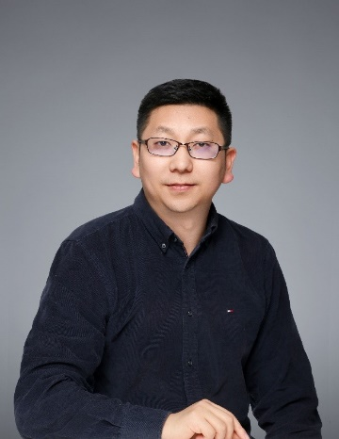
Mr. Xie Junjie, the General Manager of Taoli Chinese, graduated from Nanjing University majoring in Software Engineering. He has worked for Nintendo, Alibaba and China Merchants Bank, and once served as a technical expert and technical director in well-known Internet companies like Zhangmen 1-on-1. At present, Mr. Xie Junjie is leading the Taoli Chinese team to strive to develop multiple businesses, including HSK examination training, overseas students coming to study in China, international Chinese courses and multi-language machine translation. Taoli Chinese is taking advantage of artificial intelligence to optimize Chinese teaching experience so as to create a global Chinese learning ecological environment and also enable the brand of Taoli Chinese to shine brightly.
谢俊杰先生，桃李中文总经理，毕业于南京大学软件工程专业，先后在任天堂、阿里巴巴和招商银行任职，曾任一对一等知名互联网公司的技术专家和技术总监。如今谢俊杰正带领桃李中文团队努力打造HSK 考试培训、来华留学、国际中文课程以及多语言机器翻译等多项业务。桃李中文借助人工智能优势优化教学体验，努力营造全球中文学习生态环境，推动了中文在全球的传播，也让桃李中文的品牌大放异彩。

Chen Ye

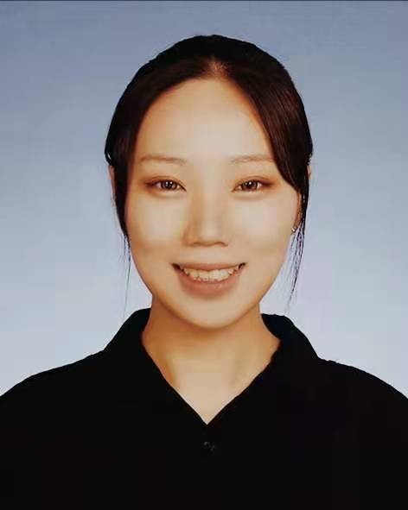
Formerly a dispatched Mandarin teacher at the Confucius Institute of Peking University and UCL, Chen Ye was named the 2023 Global Digital Gold Medal Lecturer by the Chinese Language Alliance and received the 2024 Chinese Language Alliance Gold Medal for Digital Resource Application Case Study (PBL Teaching Method). She has taught at UCL Academy and Seoul International School and served as a member of the question-setting committee for Korea’s Chinese College Entrance Exam mock tests (2021). She led the development of an innovative vocabulary software project under Center for Language Education and Cooperation (CLEC,China)’s resource development initiative. Chen Ye has been invited multiple times to conduct training for overseas volunteer Mandarin teachers of CLEC, as well as Chinese teacher associations in Canada, the UK, and South Korea, training over 3,000 teachers cumulatively. Her research has been presented at international conferences, including the European Association of Chinese Teachers’ Symposium, and she has been invited to deliver lectures on AI-empowered education at the Confucius Institutes of the London School of Economics and the University of Groningen in the Netherlands.

陈烨，前北大UCL孔院公派教师，2023年中文联盟全球数字化金牌讲师，2024年获中文联盟金牌数字资源应用案例（PBL教学法）。曾任教于UCL附中和首尔国际高中，并担任韩国汉语高考模拟题出题委员（2021）。曾主导研发语合中心资源建设项目-创新词汇软件1项。多次受邀为语合全球海外志愿者及加/英/韩等国中文教师协会作培训，累积培训人数超3000人。其研究成果发表于欧洲汉语教师协会研讨会等多项国际会议，并受邀在伦敦政经大学孔院及荷兰格罗宁哥大学孔院作AI赋能教育讲座。

Professor Xu Xin
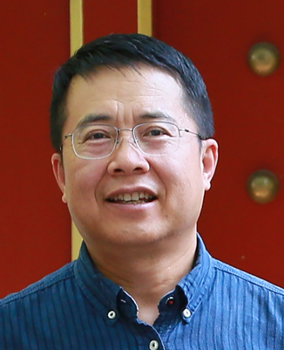
Xu Xin is an Associate professor at Beijing Foreign Studies University (BFSU). He obtained his Bachelor's degree in English from BFSU. Later, he pursued his postgraduate studies and received a Master's degree in Linguistics from Lancaster University in the UK and another Master's degree in Information Management from Peking University. His research areas mainly concentrate on Corpus Linguistics as well as Computer-Assisted Translation and Teaching. Xu Xin used to be engaged in the course development and teaching of English as a second language in distance mode at the Online Education Institute, BFSU. Besides, he once worked as Teaching Director of International Foundation Programs at the School of Continuing Education, BFSU. Now, he is serving as the Chinese Director of the Online Confucius Institute jointly established by Beijing Foreign Studies University and The Open University in the UK, responsible for organizing international Chinese teaching as well as promoting Chinese culture and global academic collaborations.
许新，北京外国语大学副教授，拥有北京外国语大学英语专业学士学位、英国兰卡斯特大学语言学硕士学位以及北京大学信息管理专业硕士学位。其研究领域包括语料库语言学以及计算机辅助翻译与教学，曾在北京外国语大学网络教育学院负责远程英语课程的开发与教学工作，并在北京外国语大学继续教育学院负责国际预科课程设计与教学管理工作，现任英国开放大学网络孔子学院中方院长，组织国际中文教学、推广中国文化、促进国际学术合作。

Dr Zsuzsanna Bárkányi
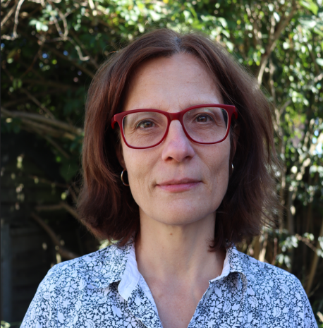
Dr Zsuzsanna Bárkányi is a Senior Lecturer in Spanish at The Open University, United Kingdom. Previously, she worked as a Speech Linguistic Project Manager for Google’s text-to-speech synthesis team. Zsuzsanna holds a PhD in Spanish Linguistics by Eötvös Loránd University, Hungary. Her research focuses on foreign language speaking anxiety and L2/L3 Spanish pronunciation learning and teaching. She widely published on the interface of phonetics and phonology, specifically on voicing related processes. Zsuzsanna has expertise in teacher training and online and distance language teaching and learning.
苏珊娜·巴尔卡尼（Zsuzsanna Bárkányi）博士是英国开放大学西班牙语高级讲师，曾在谷歌文本转语音合成团队中担任语音语言项目经理。苏珊娜拥有匈牙利罗兰大学的西班牙语语言学博士学位，其研究重点是外语口语焦虑以及第二语言/第三语言西班牙语发音的学习与教学。她在语音学和音系学的交叉领域，特别是与浊音相关的过程方面发表过大量著作。苏珊娜在教师培训以及在线和远程语言教学方面也颇有专长。

Dr Kan Qian
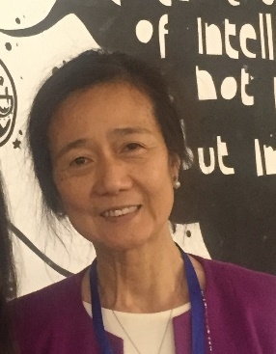
Dr Kan Qian is Director of the Online Confucius Institute at The Open University. She is Senior Lecturer in Chinese in the School of Languages and Applied Linguistics at The Open University. She is also Senior Fellow of The Higher Education Academy (UK), and Bye-Fellow of Lucy Cavendish College at the University of Cambridge. She supervises doctoral students in the field of language teaching and technology. Her research focuses on the use of technologies for the learning and teaching of languages: mobile language learning, interactions in online discussion forums, e-Tandem learning and online language learning design including MOOC design. She recently co-edited the Special Issue: Technology-Enhanced Teaching of Chinese as a Foreign Language, for the Journal of the ChinaCALL (August 2023). For her publications, please visit this page.
阚茜博士 - 英国高等教育科学院高级院士 - 现任英国开放大学网络孔子学院院长、语言及应用语言学学院高级讲师、语言学习博士导师。她也是剑桥大学露西·卡文迪学院荣誉院士。她的研究领域注重现代信息技术在外语教学中的应用；移动学习对外语教学和学习的影响；在线论坛对语言学习的作用；仿真学习（包括电子搭档学习）；在线课程设计，包括慕课设计。她最近为 ChinaCALL 杂志主编了特刊：Technology-Enhanced Teaching of Chinese as a Foreign Language（2023 年 8 月）。她的其它学术出版， 请浏览此页面。

